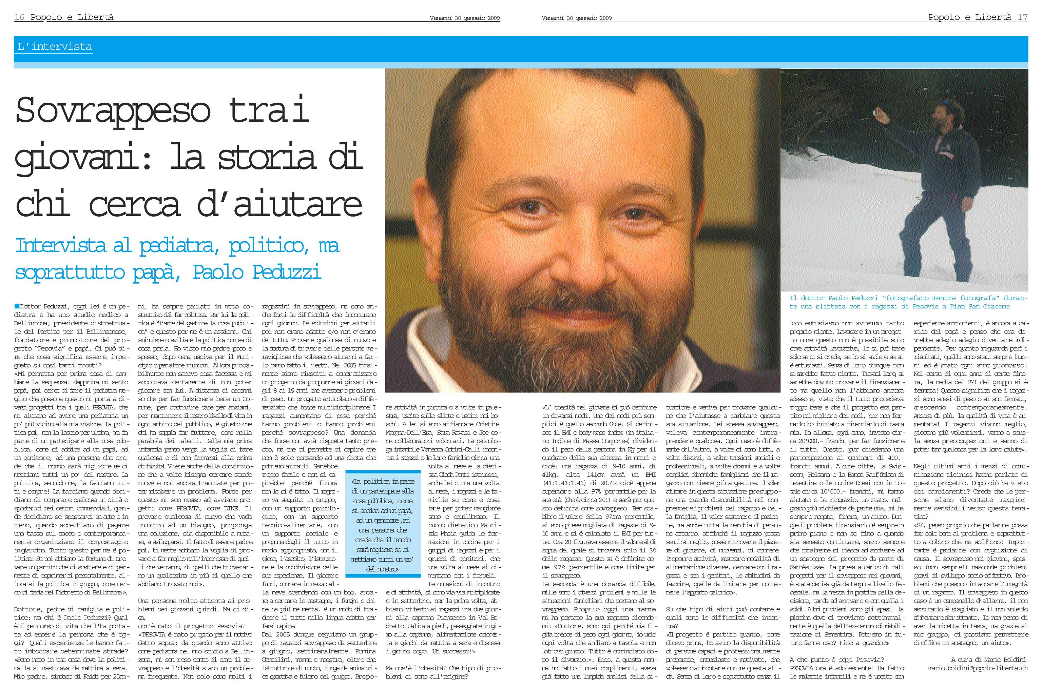
Thank you for trying DocSmartz.
Please note that DocSmartz trial version converts only limited pages of your document.
To convert your complete document, you need to purchase DocSmartz.
To order, please visit: http://www.docsmartz.com/asp/order_form.asp

